

Practices for Secure Software Report

Table of Contents
Document Revision History 3
Client 3
Instructions 3
Developer 5
1. Algorithm Cipher 5
2. Certificate Generation 7
3. Deploy Cipher 7
4. Secure Communications 8
5. Secondary Testing 8
6. Functional Testing 10
7. Summary 10
8. Industry Standard Best Practices 11

Document Revision History

Version | Date | Author | Comments
1.0 | 16 Feb 2026 | Talon Douglas

Client



Instructions

Submit this completed practices for secure software report. Replace the bracketed text with the relevant information. You must document your process for writing secure communications and refactoring code that complies with software security testing protocols.

- Respond to the steps outlined below and include your findings.
- Respond using your own words. You may also choose to include images or supporting materials. If you include them, make certain to insert them in all the relevant locations in the document.
- Refer to the Project Two Guidelines and Rubric for more detailed instructions about each section of the template.

Developer
Talon Douglas

Algorithm Cipher
Because Artemis Financial handles large financial portfolios, it is critical that the data they hold on to is secured using encryption. It is important that the encryption used is strong and fast. AES-256 is the standard for most encryption use-cases and is considered the strongest AES algorithm in practice (GateKeeper, n.d.; Kiteworks, n.d.), so that’s what we’ll recommend. The AES algorithm is a symmetric block cipher that can encrypt and decrypt digital information (National Institute of Standards and Technology [NIST], 2023). AES-256 works by encrypting (and decrypting) data in 128-bit blocks, using a cryptographic key of 256 bits long (NIST, 2023). This long of a key length is important because it provides 2²⁵⁶ possible combinations, making brute force attacks incredibly infeasible with current technology.
Symmetric encryption means the key that’s used to encrypt the data is the same key used to decrypt the data. This is different from Asymmetric encryptions which use mathematically linked keys where one key is typically public while the other is private, such as in RSA encryption (GeekForGeeks, 2025). Further, in a block cipher, the data is encrypted in fixed-length blocks. This is different from stream ciphers that encrypt data one byte at a time (Encryption Consulting, 2024).
Generating random numbers is also a critical part of encryption. Since AES-256 uses the same key for both encryption and decryption, that key also needs to be very secure. Keys should be generated using a NIST-approved cryptographically secure random number generator (Kiteworks, n.d.; Manico & Detlefsen, 2014).

Now, when it comes to implementing a file checksum, SHA-256, a hash algorithm, is recommended. This is because hash functions perform one-way transformations meant to authenticate the integrity of data, not really to encrypt it. (GeekforGeeks, 2025). Hash functions, like members of the SHA-2 family of hashes or the MD5 hash, take an input of (almost) any size and perform various functions on the data in order to produce a pseudo-unique output of a specific size. For example, SHA-256 can take an input of any size less than 2⁶⁴ bits, and it will always produce an output, or a ‘hash’, of 256 bits (NIST, 2015; Encryption Consulting, 2024).
Hashes are incredibly useful because putting the same data through the same hash algorithm will always produce the same output. Therefore, the hash value of received data can be compared to the hash value of data as it was sent to determine if the data was altered (Microsoft, 2023).
Encryption and cryptography as a whole are very old practices, with Ancient Spartans encrypting their military communications as far back as 650 BC. However, encryption technology has advanced significantly in the last 100 years (Schneider, n.d.). In the early 1970’s, the National Bureau of Standards, now NIST, put out a request in the U.S. for a block cipher that could become the national standard. They ended up choosing an algorithm developed by IBM called Lucifer, which later became DES before it was eventually broken and determined unsafe due to the short key length (Sudhpurwala, 2023). In 2001, NIST chose the Advanced Encryption Standard, or AES, to be the replacement as the standard and it was later adopted by multiple government agencies (Digicert, 2022). Today, encryption standards are set by organizations such as the NIST (Weinberger, 2024), and requirements are set by various governing bodies like U.S. Department of Health and Human Services for healthcare security (Alder, 2026).

Certificate Generation
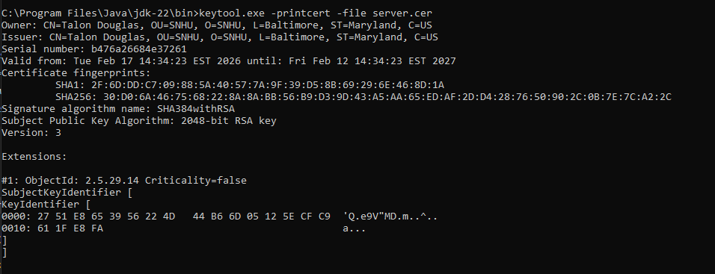

Deploy Cipher
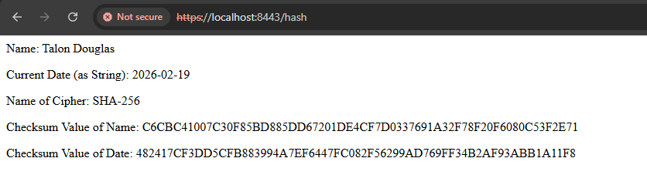
I’d like to explain here why I deployed the hash twice. In a previous assignment, we were instructed to create a function to deploy a hash called bytesToHex(). While this did work when I implemented it in this code, I chose to revise the code in order to closer imitate what I believe would be aligned with the given scenario of implementing a data verification step in the form of a checksum. I’ll re-explain this later in the assignment, but the reason I believe this more closely aligns with the scenario is the hardcoded name will not change, but each day, the date will change. Therefore, I was able to demonstrate an example of taking data that may change (like verifying multiple different files) and still being able to hash them for the verification. The new function allows me to pass any data through the checksum, instead of just data that is hardcoded, which would introduce a vulnerability.

Secure Communications
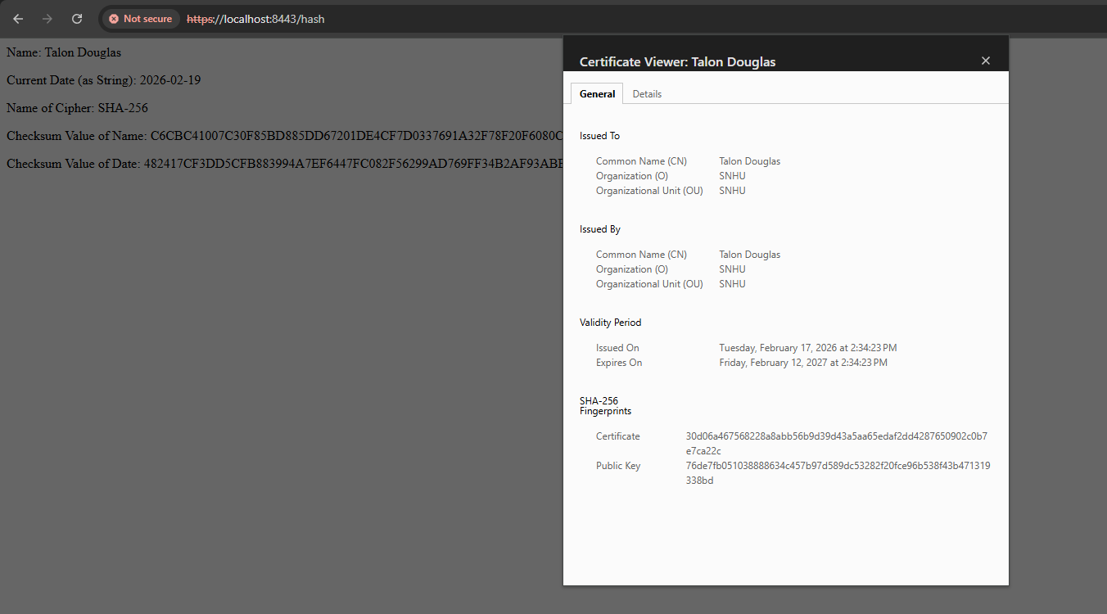
I included the certificate information to show that the application.properties file was configured correctly. However, you are still able to see the ‘HTTPS:’ in the URL bar.

Secondary Testing
No additional dependency vulnerabilities were introduced following the refactoring.
Dependency check BEFORE refactoring:
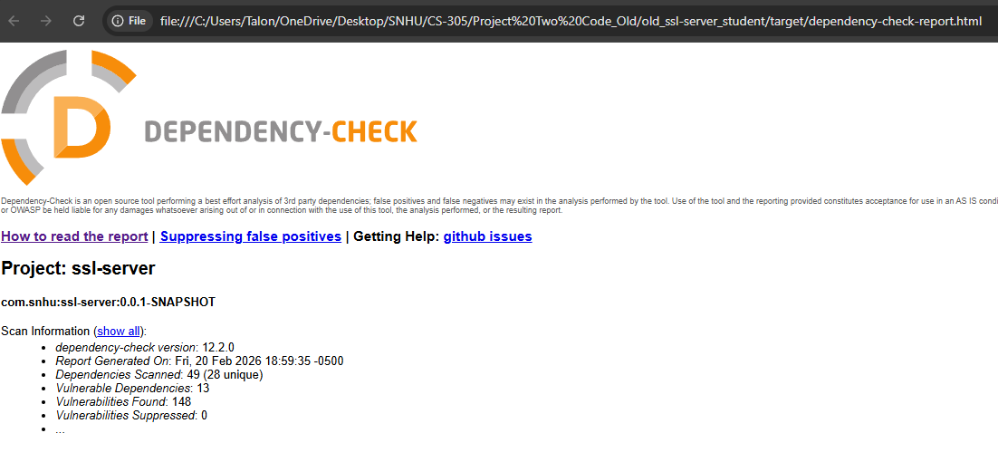

Dependency check AFTER refactoring:
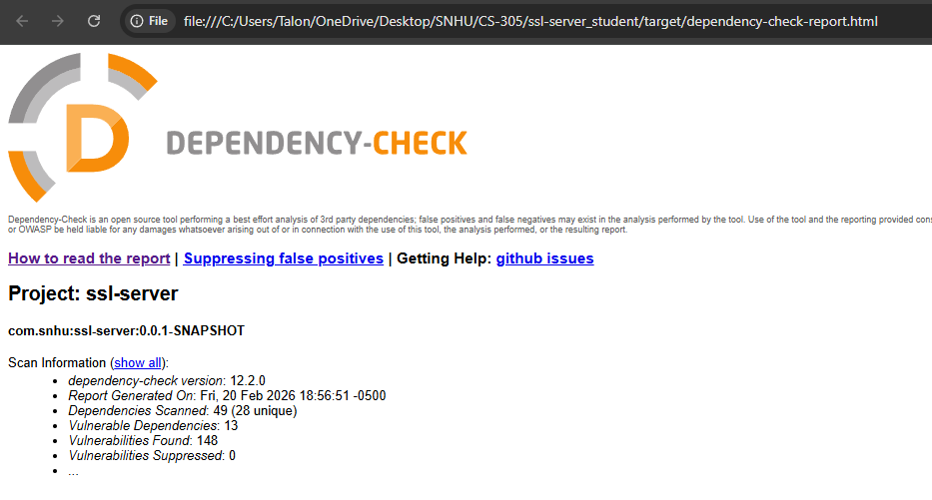

Functional Testing

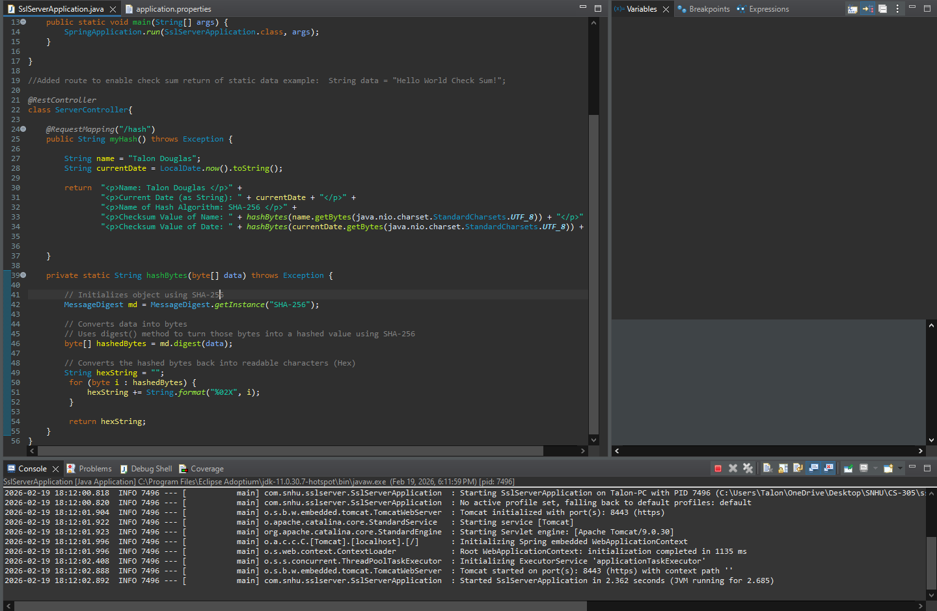
This software uses a self-signed certificate. Because this software is in development and not operational, this is accepted, however a 3rd party certificate issued by a trusted Certificate Authority would be the appropriate alternative in a deployed software tool. Additionally, having a publicly accessible endpoint would be a security vulnerability if this software was operational. Again, this is accepted because this is in development. However, ideally, this endpoint would be inaccessible without proper authentication through access control.
Syntactically, there were quite a few unused imports that were not required for the program. They were removed to increase readability.

Summary
The areas of vulnerability assessment that are most applicable to this project are cryptography, client / server, code error, and code quality. I addressed cryptography through implementing a checksum verification and enabling HTTPS using a self-signed certificate. Again, a self-signed certificate would not be trusted by a public client, but while in development, it will be fine. The client/server portion is also addressed through implementing HTTPS, securing client/server communications. Both of these are added layers of security that promote the CIA triad: Confidentiality, Integrity, and Availability (Fortinet, n.d.). Confidentiality is supported by enabling HTTPS which encrypts communications, and integrity is supported through the checksum verification. These layers promote security within the application.
For code error handling, the only minor concern deals with the hashBytes() function, where I needed ‘throws Exception’, because the exception “NoSuchAlgorithmException” can technically come up due to the getInstance() method to hash using SHA-256. However, the likelihood of this happening seems minimal because the error is only thrown if the algorithm isn’t supported by any registered provider used by the library (Oracle, n.d.).
Lastly, for code quality, I removed unused imports to promote readability. I also refactored the hashing function to make it easier to reuse, improving maintainability.

Industry Standard Best Practices

Best practices were applied during the refactoring process through implementing both HTTPS and a checksum verification. HTTPS provides encryption for client-server communication. While there isn’t a third-party certificate authority to verify trust for the client, the self-signed certificate is only used for development. Additionally, the checksum verification is being implemented using SHA-256, a NIST-approved standard (NIST, 2015). Maintaining confidentiality and integrity for data are critical industry practices. Following established standards reduces the risk of introducing security vulnerabilities.
Further, by performing both static dependency checks and continuous manual checks of the software, I’ve identified where potential weak points may have been introduced so that I can alleviate them ahead of time. Refactoring the code also contributed to industry best practices. By making the program easier to read, it becomes easier to identify vulnerabilities and maintain security.

References
Alder, S. (2026, January 3). HIPAA Encryption Requirements. The HIPAA Journal. https://www.hipaajournal.com/hipaa-encryption-requirements/
Digitcert. (2022, December 29). The History of Cryptography. https://www.digicert.com/blog/the-history-of-cryptography#:~:text=In%20the%201970s%2C%20IBM%20created,22%20hours%20and%2015%20minutes.
Encryption Consulting. (2024, March 4). What is SHA-256?. https://www.encryptionconsulting.com/education-center/sha-256/
Encryption Consulting. (2024, March 4). What is Stream Cipher and Block Cipher?. https://www.encryptionconsulting.com/education-center/stream-cipher-and-block-cipher/
Fortinet. (n.d.). CIA Triad. https://www.fortinet.com/resources/cyberglossary/cia-triad
GateKeeper. (n.d.). AES-256 Encryption. https://gkaccess.com/support/information-technology-wiki/aes-256-encryption/
GeekForGeeks. (2025, November 21). Asymmetric Encryption. https://www.geeksforgeeks.org/computer-networks/what-is-asymmetric-encryption/
GeekForGeeks. (2025, July 23). Cryptographic Hash Functions. https://www.geeksforgeeks.org/competitive-programming/cryptography-hash-functions/
Kiteworks. (n.d.). Everything You Need to Know about AES-256 Encryption. https://www.kiteworks.com/risk-compliance-glossary/aes-256-encryption/
Manico, J. & Detlefsen, A. (2014, September). Iron-Clad Java. McGraw Hill Computing. https://learning.oreilly.com/library/view/iron-clad-java/9780071835886/
Microsoft. (2023, January 3). Ensuring Data Integrity with Hash Codes. https://learn.microsoft.com/en-us/dotnet/standard/security/ensuring-data-integrity-with-hash-codes
National Institute of Standards and Technology. (2023, May 9). Advanced Encryption Standard (AES). https://doi.org/10.6028/NIST.FIPS.197-upd1
National Institute of Standards and Technology. (2015, August). Secure Hash Standard (SHS). http://dx.doi.org/10.6028/NIST.FIPS.180-4
Oracle. (n.d.). Class MessageDigest. https://docs.oracle.com/en/java/javase/21/docs/api/java.base/java/security/MessageDigest.html
Schneider, J. (n.d.). A Brief History of Cryptography: Sending Secret Messages Throughout Time. IBM. https://www.ibm.com/think/topics/cryptography-history
Sidhpurwala, H. (2023, January 12). A Brief History of Cryptography. Red Hat. https://www.redhat.com/en/blog/brief-history-cryptography
Weinberger, J. (2024, September 17). Exploring NIST Guidelines and FIPS 140-3 in a Changing Security Landscape. ShardSecure. https://shardsecure.com/blog/encryption-standards-nist

